**Post Visit Care**

This page shows you a condition management for your pet. Here, you will see the find user, find pet and find condition. You also have the option to edit condition, delete condition and add condition.

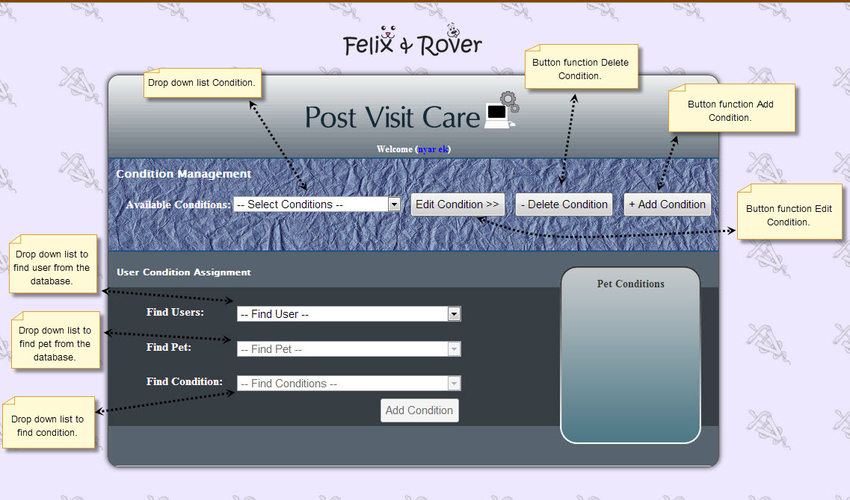

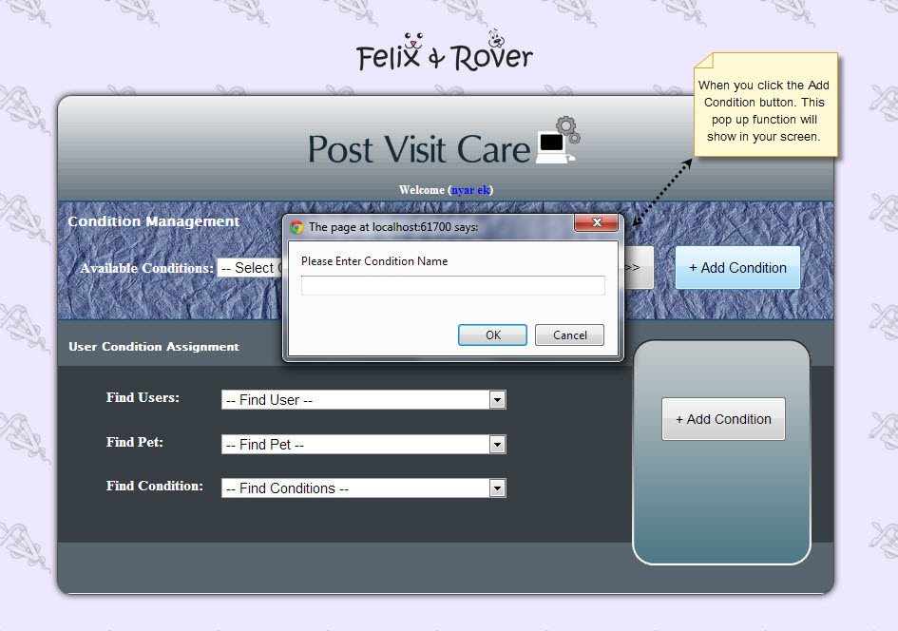

This page shows you the WYSIWYG Editor in edit condition.

